N = 100000

n = 100

a/sum(a)

ans =

|  |  |  |  |
| --- | --- | --- | --- |
| 0.5084 | 0.1688 | 0.0841 | 0.0492 |
| 0.0328 | 0.0252 | 0.0174 | 0.0143 |
| 0.0109 | 0.0089 | 0.0075 | 0.0062 |
| 0.0053 | 0.0047 | 0.0044 | 0.0036 |
| 0.0030 | 0.0030 | 0.0028 | 0.0024 |
| 0.0020 | 0.0021 | 0.0017 | 0.0018 |
| 0.0014 | 0.0015 | 0.0013 | 0.0013 |
| 0.0010 | 0.0011 | 0.0009 | 0.0009 |
| 0.0010 | 0.0008 | 0.0008 | 0.0007 |
| 0.0006 | 0.0006 | 0.0006 | 0.0148 |
|  |  |  |  |

Value for mean of K and K(x)

mean(K)

ans = 4.1665

mean(K(x))

ans = 1

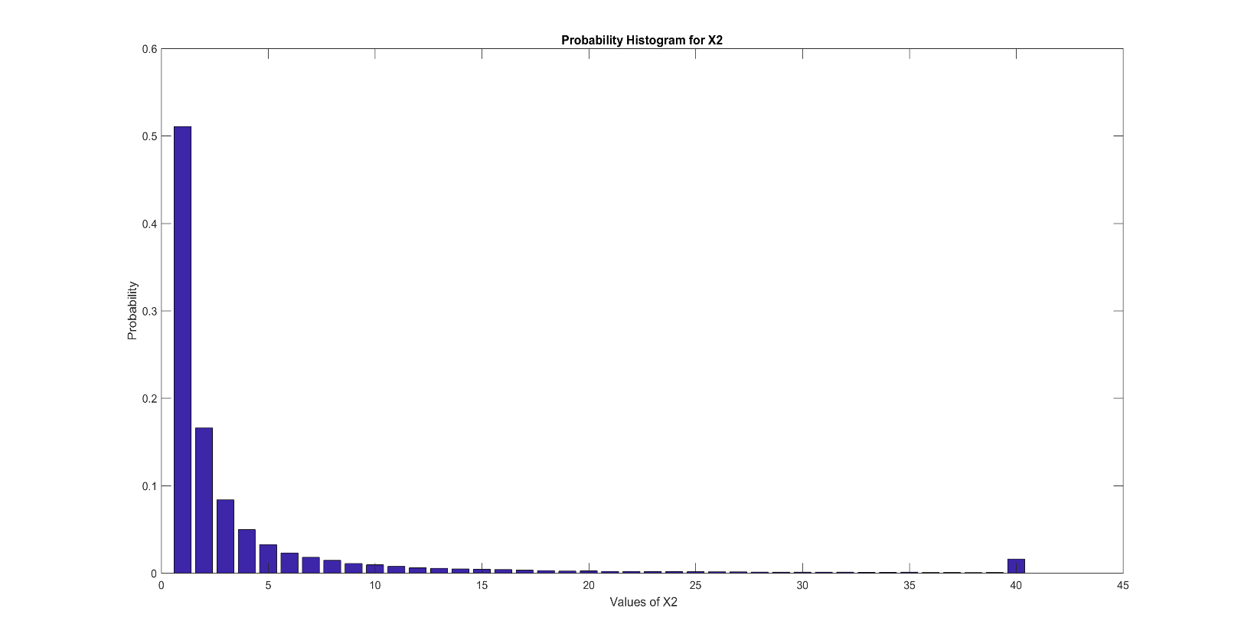N = 100000

n = 100

a/sum(a)

ans =

|  |  |  |  |
| --- | --- | --- | --- |
| 0.3106 | 0.1387 | 0.0898 | 0.0646 |
| 0.0488 | 0.0377 | 0.0312 | 0.0255 |
| 0.0211 | 0.0188 | 0.0162 | 0.0139 |
| 0.0117 | 0.0104 | 0.0100 | 0.0090 |
| 0.0078 | 0.0073 | 0.0066 | 0.0060 |
| 0.0058 | 0.0053 | 0.0053 | 0.0046 |
| 0.0043 | 0.0042 | 0.0035 | 0.0036 |
| 0.0029 | 0.0030 | 0.0030 | 0.0027 |
| 0.0027 | 0.0027 | 0.0024 | 0.0024 |
| 0.0019 | 0.0024 | 0.0020 | 0.0492 |

Value for mean of K and K(x)

mean(K)

ans = 7.4793

mean(K(x))

ans = 6

A close up of a logo

Description generated with very high confidence